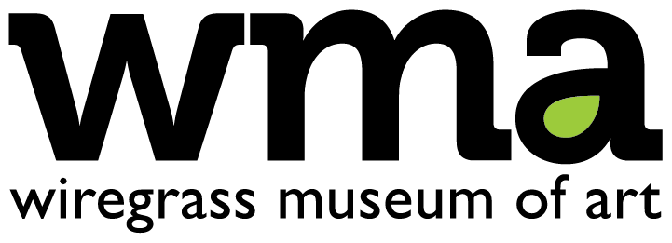
2020 Youth Art Month Student Artwork Sheet

When submitting multiple works, fill out this form and make a copy for your records. This helps ensure that all works of art are accounted for during the exhibition process.

School: _____________________________________________________________ # of works: __________
Teacher Name: ______________________________ Teacher Email: _________________________________

Student Name | Title of Artwork | Grade
Electronic version available online at www.wiregrassmuseum.org/youth-art-month/

