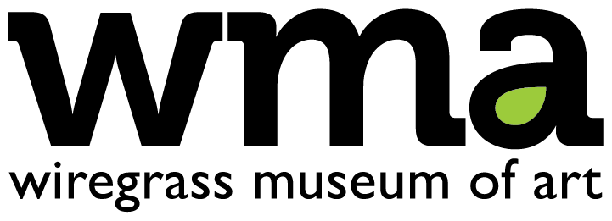

2020 Youth Art Month Exhibition Entry Form

Postcard invitations will be mailed to the student address provided. Show acceptances will be sent to the submitting teacher or parent/guardian’s email. Complete form entirely and neatly, then affix to back of each artwork securely with masking tape.

Student Artist’s Full Name: _______________________________________________________

Student Address: _______________________________________________________________

City: ___________________________________ State: ____________ Zip: _______________

School: _______________________________ County: _________________ Grade: _________

Teacher’s Name: ________________________ Teacher’s Email: _________________________

Artwork Title: _________________________________________________________________
Note: it cannot be ‘Untitled’ unless there are parenthesis afterwards. Ex. Untitled (Boat Scene)

Medium: _________________________________ Dimensions: ________________________

Honesty Statement

By signing below, I certify that this submitted artwork is my original creation. I received no aid other than instruction from my teacher. My work does not contain copyrighted material. If my artwork references other published work, I have properly credited the original source. I understand that I may be disqualified if I do not adhere to these statements.

Student Signature: ___________________________________________ Date: _____________

By signing below, I certify that this submitted artwork is the student’s original creation. The only aid received was my instruction to the student. Their artwork does not contain copyrighted material. If their artwork references other published work, I have ensured the original source has been properly credited. I understand the work may be disqualified if these statements are not adhered to.

Teacher Signature: ___________________________________________ Date: _____________

Electronic version available online at www.wiregrassmuseum.org/youth-art-month/

